Scan Report
Zhen Xu
- Sample to scanned
PM-1055 050N, inner diameter L=32mm, Gap h=14mm

- Scanning System with probe
The three component Hall Probe measuring Bx, By, Bz Hall probe has better than 0.1% amplitude accuracy and 150 x 10 x 150um (x, y, z) sensitive volume.
The probe is installed on a Senis Mapper (MMS-1A-RS with 2um linear positioning accuracy).

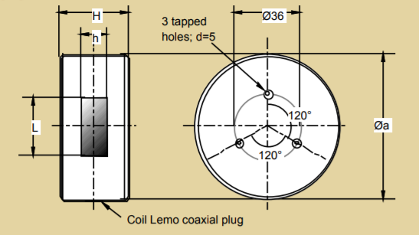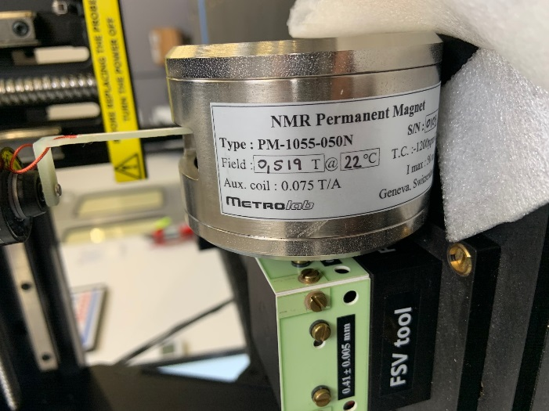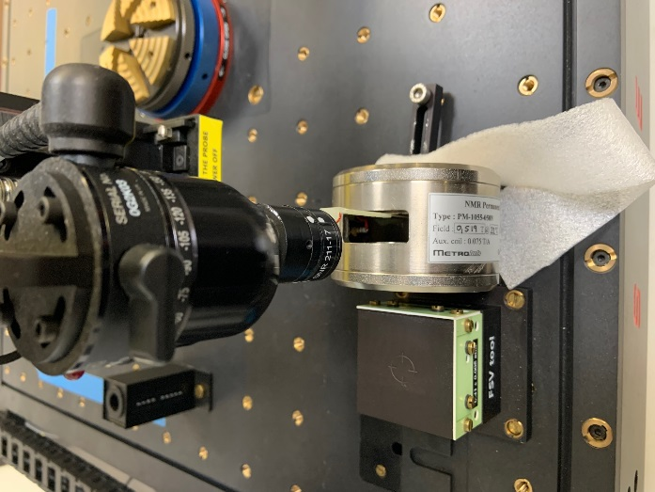

- Scanning Results
The field component, Bx, perpendicular to the Pole surfaces is scanned in several y-z planes with y, z scan increments of 0.5mm. The mapped field component Bx corresponds to Probe field component By with 10um magnetic field sensitive volume.
Scan in square shape 12mm*12mm. Scan in 9 YZ Planes with X locations equal to -4, -3, -2, -1, 0, 1, 2, 3, 4mm with scan index 1 to 9 shown below.
With depth of center area of 7-8mm in x and area of 12mm*12mm, field deviation < 0.03%.

