How to increase the safety of your production facilities with residual current monitoring

More and more often, necessary safety inspections of low-voltage installations in production plants are being avoided. In addition to financial reasons, the measurements that have been suggested by standards for decades are now a danger to the electronic components which are used in many production plants. Continuous residual current monitoring is often a cheaper and better way to ensure the safety of the installations. In order to interpret and evaluate the measurement results correctly, some special aspects of this measurement method must be taken into account. Due to DC and high frequency components a type B+ residual current monitor is often recommended. The Danish company is offering now a type B+ device, with which an FFT analysis and an oscilloscope view is possible.

Disadvantages of the periodic verification of low voltage installations according to the IEC 60364-6
In many production plants that have been delivered in recent years, frequency converters are installed in connection with electric motors. In order to comply with the national safety guidelines and the requirements of the respective professional associations, regular tests must be carried out on the systems. In international standardization, these test procedures are regulated in IEC 60364-6:2016. Many operating instructions for frequency converters explicitly prohibit subjecting the frequency converter to an insulation test. Therefore, these devices should be disconnected during the test. However, it often happens that carelessness occurs, and specific instructions are frequently missing in the manufacturers' manuals, so that frequency converters are damaged due to the high DC voltage levels during the insulation test. In table 1 the specified voltage levels are listed. Switching power supplies and other devices with electronic circuits can also be damaged by the insulation test.
Table 1: Test voltages for insulation tests according to IEC 60364-6
Nominal circuit voltage  [V] |  | Test voltage d.c.  [V] | Minimum insulation resistance  [MΩ]
SELV and PELV |  | 250 | 0.5
Up to and including 500 V, including FELV |  | 500 | 1
Above 500 V |  | 1000 | 1

Many companies are therefore concerned about the time-consuming and costly repeat inspections of the machines, which are only a snapshot of the condition of the plant.
RCDs and their different protection targets
Continuous monitoring would be desirable, so that system malfunctions could be detected and corrected at an early stage. Residual current devices (RCDs) have been available for plant monitoring for many years. For plant protection often an RCD with a tripping current of 500 mA is chosen.
Table 2: The relationship between the achievable protection level and the rated residual current for RCDs type A
Rated residual current max. I_{Δn} | Additional protection | Fire protection | Fault protection / Plant protection
 | Protection against direct contact | Protection against fire risk | Protection against indirect contacts
30 mA | X | X | X
100 mA |  | X | X
300 mA |  | X | X
> 500 mA |  |  | X

Besides the protection levels the type of the fault current wave form has also been taken into account.

Type of RCD | Types of wave form detected by RCDs
 | alternating current 50/60 Hz | alternating current up to 1000 Hz | pulsating current with DC components | multifrequency current generated by the single-phase inverter | multifrequency current generated by the three-phase inverter
AC | X
A | X |  | X
F | X |  | X | X
B | X | X | X | X | X
A S (selective) | X |  | X
B S (selective) | X | X | X | X | X

The disadvantage with this type of protection is that the power supply trips when a level between 50 and 100 percent of the tripping threshold is reached, causing the plant to shut down abruptly. False alarms caused by switch-on transients are very annoying and often lead to time delays in the production process. Furthermore, with this machine monitoring, insulation measurement is still mandatory because no RCD cannot provide measurement values according to the IEC 62020.

Residual current monitoring in connection with universal measurement devices
In some industries, residual current sensors in the low-voltage distribution systems have also been installed for these reasons during the rollout of energy management systems. This was to detect deteriorating insulation resistance of the plant at an early stage. The output signals of the residual current sensors were often connected to universal measuring devices, which measure the power and some power quality parameters.
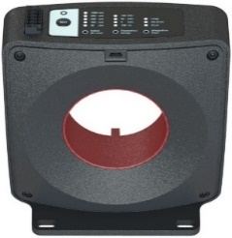
PEN conductor from transformer
plant 1 with frequency converter / switched-mode power supply
R iso C1
R iso C1
plant 2 with frequency converter / switched-mode power supply
R iso C2
L2
L3
N
L1
PE
CEP*-measuring
The entire residual current of the system flows here.
I_{res plant 1}
I_{res plant 2}
R iso L1
R iso L2
R iso L3
I_{res ∑}
R iso C2
R iso N
Current sensors for energy measurement
I_{res∑}
R iso p1

R iso p1

R iso p2

R iso p2

R iso L1

R iso L2

R iso L3

R iso N

*CEP = central earthing point
Figure 1: Energy monitoring and residual current measurements in low voltage TN-S grid

In larger plants, residual currents higher than 30 mA were often measured. The residual current levels also varied depending on the machine status and the activated individual loads of the entire system. An interpretation of the measured levels regarding the insulation properties of the system was often not possible for the respective electrician. The question arises as to what system related residual current levels are to be expected on machines and whether there are defined upper limits that must be complied with.

Permitted residual current levels of equipment and loads
In international standardization, IEC 61140:2016 provides further assistance. Point 7.6.3.3 of this standard defines the maximum levels of current on the protective earth conductor of equipment and loads in normal operation up to 1 kHz.
Table 3: Maximum levels of current on the protective earth conductor of equipment and loads in normal operation up to 1 kHz
Rated current of current-using equipment  a.c. | Maximum protective conductor current  for frequencies up to 1 kHz
0 < I ≤ 2 A | 1 mA
2 A < I ≤ 20 A | 2.5 mA/A
I > 20 A | 10 mA

The protective conductor currents mostly correlate with the measured residual current levels because EMC filters are connected between the individual phases and the protective conductor. Thus, the filter currents are routed to the protective earth conductor. However, capacitive couplings can also cause high-frequency currents to flow back to the current source through grounded heating systems or other pipeline systems.
Since DC residual currents can also occur in many loads such as frequency converters, there is the following version to read under 7.6.3.4.
…In normal use, a.c. current using equipment shall not generate current with a d.c. component in the protective conductor that exceeds the values in in following table. This will prevent affecting the proper functioning of protective device(s) or other equipment in the installation. …
Table 4: Maximum protective conductor current d.c.
Rated current of current-using equipment a.c. | Maximum protective conductor current d.c.
0 < I ≤ 2 A | 5 mA
2 A < I ≤ 20 A | 2.5 mA/A
I > 20 A | 50 mA

The background for this requirement is that a DC component greater than 6 mA drives the inductive current transformers in the RCDs (type A and F) into saturation. Due to this magnetic exposure, the a.c. component of a residual current can no longer or only partially be transferred to the secondary side. As a result, the RCD would no longer be able to trip reliably at higher residual current amplitudes in the a.c. range. The RCD would no longer be able to trip reliably. The defined protective measure, such as personal or fire protection, could no longer be realized. If higher residual current levels in the d.c. range cannot be excluded, type B or type B+ RCDs must be used, which are able to measure the current signal from DC to 20 kHz (B+).

Residual current monitoring via the PLC
In complex industrial machines, a wide variety of electrical components form a system that is controlled via programmable logic controller (PLC). Accordingly, these plants may have higher residual current levels than in the above-mentioned tables. For example, the following values result from a production plant with a rated current of 235 A.

Figure 2: System-related residual current of a production plant with a rated current of 235 A
Even if continuous residual current monitoring can replace insulation testing due to international standardization, an analysis of the insulation resistance via the measured values shown above is not quite simple. In the plant, a wide variety of individual consumers are controlled, which in total generate different residual current levels.
For this reason, some PLC manufacturers already offer residual current sensors in their portfolio that can be connected to the PLC via machine standard signals. By linking the various machine statuses with the measured residual current levels directly after the start-up and the successful safety tests, a reliable and meaningful monitoring of the production plant can be carried out.
It should also be noted that the system-related filter currents are mostly capacitive. If resistive fault currents flow in the system, this results in a smaller increase in the measured True RMS value than assumed. In the figure below 250 mA of system-related residual current (green) is present. If a resistive fault current of 30 mA occurs in the system, the True RMS value increases only by 1.8 mA. But a residual current monitor is not approved for personal protection for this reason, among others. However, plant protection with, for example, values between 300 and 500 mA can be covered in most cases.

I_{RC} = residual current (251.8 mA)
I_{R} = resistive fault current (30 mA)
I_{C} = capacitive phase-earth current (30 mA)
I_{F} = capacitive filter current of operating equipment (220 mA)
R_{I} = ohmic insulation resistance
C_{E} = phase-earth capacitance
L3
L2
L1
N
PE
~
input filter
output filter
motor
rectifier
inverter
C_{E}
R_{I}
I_{R}
I_{C}
I_{F}
I_{F}
residual current
measurement
I_{RC}
I_{RC}
I_{R}
∑ I_{C}
∑ I_{F}
protective earth conductor
operating equipment
operating equipment
operating equipment
PLC
4-20 mA DC input
Figure 3: PLC controlled production plant with capacitive system-related residual currents and a resistive fault current
By linking the measured residual current values, with the plant states and possibly even the actual energy consumption in the plant control, a good interpretation of the measured values is possible. Alarm thresholds can be defined in relation to the measured values in the normal state of the plant.

The solution
A measurement of the insulation resistance of the installation during the periodic re-testing according to IEC 60364-6:2016 would be obsolete in the future. The Danish company Danisense offers the residual current monitor SRCMH070IB+ for plant monitoring.
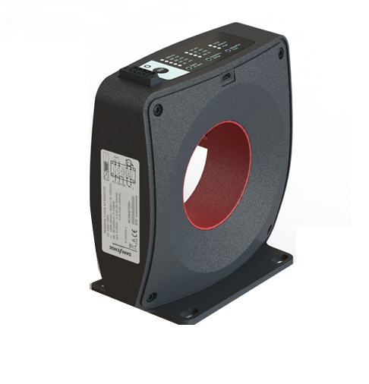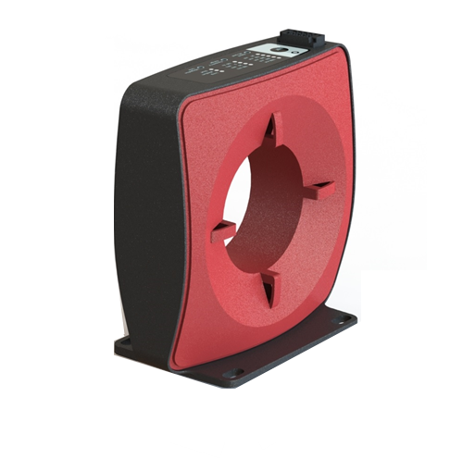
Figure 4: Residual current monitor SRCMH070IB+ according IEC 62020
With an inner diameter of 70 mm, systems up to 300 A rated current can be monitored. The connection to the PLC is made via the 4-20 mA DC output. The residual current monitor is already listed in the portfolio of some PLC manufacturers and the first plants have already been upgraded.
You can find further information under https://danisense.com/products/residual-current-monitoring/ .

Roland Buerger
Business Development Engineer
Danisense AS
rbu@danisense.com

On page 17: https://search.abb.com/library/Download.aspx?DocumentID=3AXD50000044862&LanguageCode=en&DocumentPartId=1&Action=Launch
IEC 61140, Revision 4.0, January 2016 - Protection against electric shock – Common aspects for installations and equipment

